
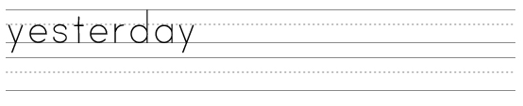
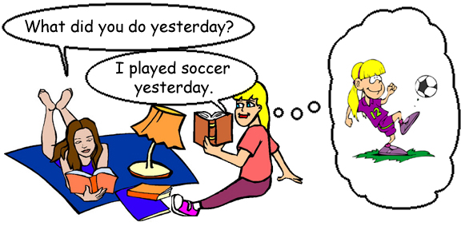
Answer the following questions:

What did you do yesterday?

What did you eat yesterday? (eat/ate)

© 2005 www.bogglesworldesl.com

Where did you go yesterday? (go/went)
Who did you meet yesterday? (meet/met)
What time did you wake up yesterday? (wake/woke)
What time did you go to bed yesterday? (go/went)
What time did have lunch yesterday? (have/had)
What did you watch yesterday? (watch/watched)
What did you buy yesterday? (buy/bought)
What did you wear yesterday? (wear/wore)

www.bogglesworldesl.com

