
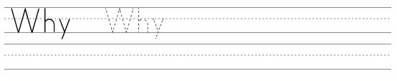
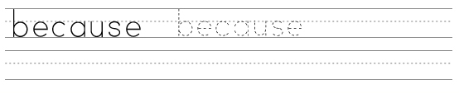
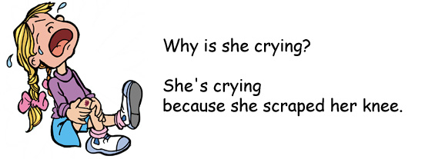

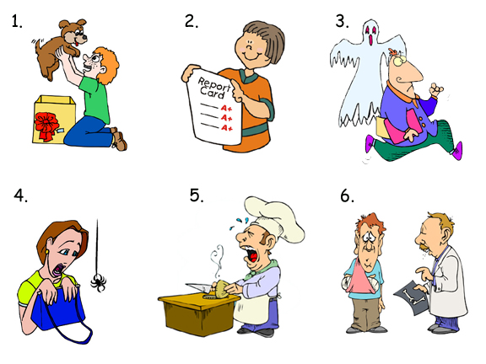

Example: crying / scraped her knee
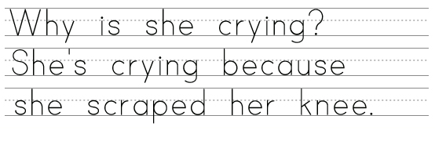

1. happy / got a puppy
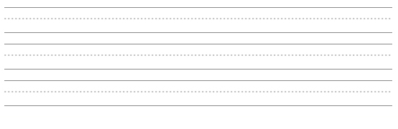

2. smiling / got a good report card
3. running / saw a ghost
www.bogglesworldesl.com
4. screaming / saw a spider
5. crying / is cutting onions
6. at the hospital / broke his arm
www.bogglesworldesl.com

