What Do You Have to Do?
What do you have to do?  I have to clean my room. | 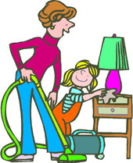
Answer the following questions:

What do you have to do at home?
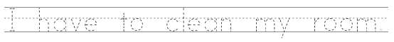

What do you have to do at school?
What do you have to do in summer?
What do you have to do in winter?

What do you have to do at night?
What do you have to do in the morning?
www.bogglesworldesl.com

