What Do You Usually Do?
What do you usually do in the evening?  I usually read  comic books. | 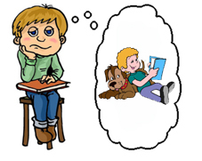

What time do you usually get up?

What time do you usually eat breakfast?

What time do you usually go to school?

What do you usually do after school?
What do you usually eat for lunch?
What do you usually eat for breakfast?
What do you usually wear to school?
What do you usually do in the evening?
What do you usually do on the weekend?
What do you usually watch on TV?
www.bogglesworldesl.com

