
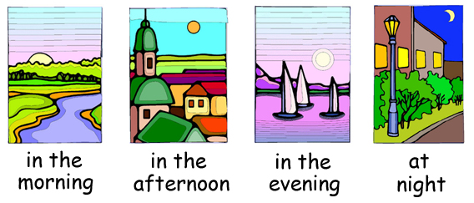

Go to bed
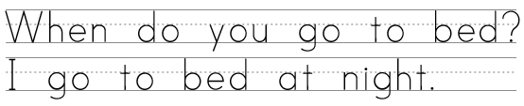

Eat dinner


Wake up

Have lunch
Dream
Start school
Finish school
Eat breakfast
Play with your friends
Watch TV
Wear Pajamas
Get dressed
www.bogglesworldesl.com

