
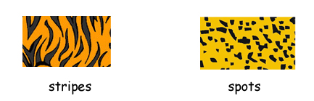
What color are tigers?
 | 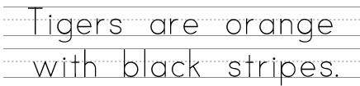
What color are leopards?
 | 
What color are zebras?
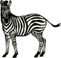
What color are cows?
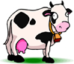

© 2005 www.bogglesworldesl.com
What color are clown fish?

What color are ladybugs?
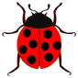
What color are Dalmatians?

What color are bees?

Can you think of any animals with stripes or spots?
Stripes |  | Spots
© 2005 www.bogglesworld.com

