
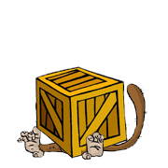 | under  The monkey is under the box.

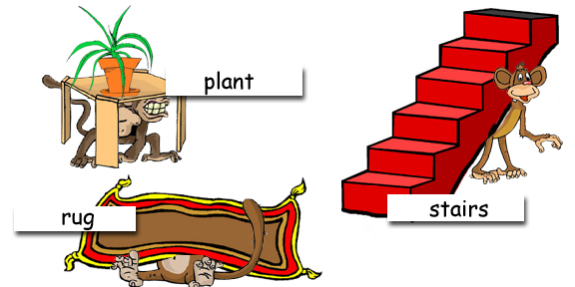

Where are the monkeys?

www.bogglesworldesl.com

