
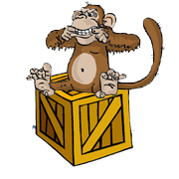 | on  The monkey is on the box.

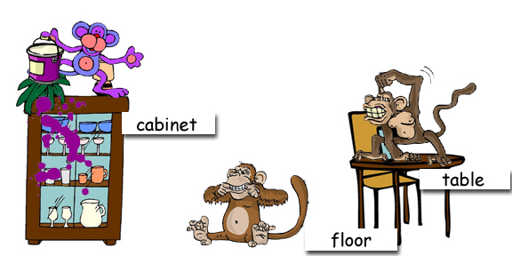

Where are the monkeys?

www.bogglesworldesl.com

