
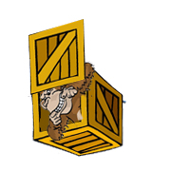 | in  The monkey is in the box.

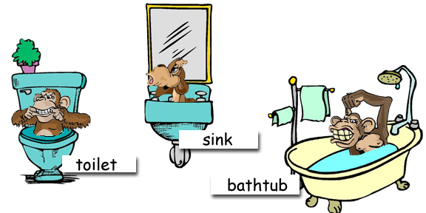

Where are the monkeys?

www.bogglesworldesl.com

