
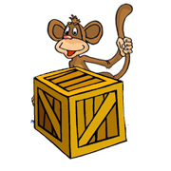 | behind  The monkey is behind the box.
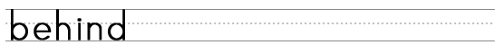
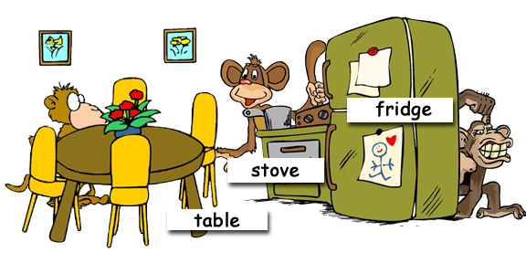

Where are the monkeys?
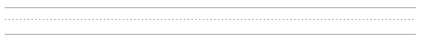
www.bogglesworldesl.com

