
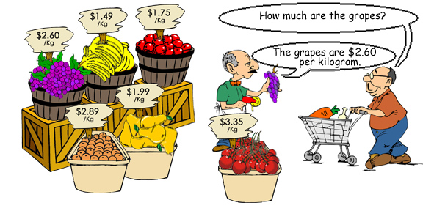
Practice writing

(1) | 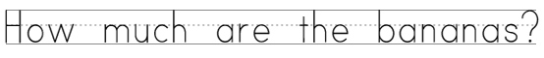
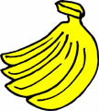  bananas |  | 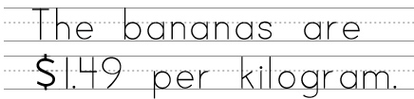
(2) | 
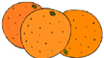  oranges |  | 
© 2005 www.bogglesworldesl.com

(3)
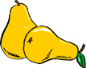
pears
(4)
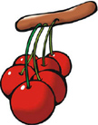
cherries
(5)
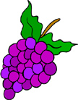
grapes
(6)
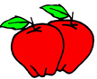
apples

© 2005 www.bogglesworldesl.com

