 |  | 

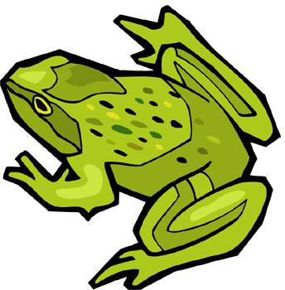  Frogs | 

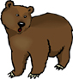  Bears | 

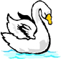
Swans


Elephants


Cats
© 2005 www.bogglesworldesl.com

