 |  | 

  Apples | 

  Oranges | 


Bananas

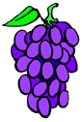
Grapes


Blueberries
© 2005 www.bogglesworldesl.com

