 |  | 
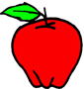  A red apple | 
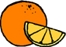  An orange orange | 
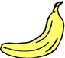  A yellow banana | 
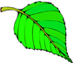  A green leaf | 
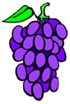  Purple grapes | 
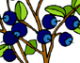  Blue blueberries | 
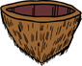  A brown coconut | 
  White clouds | 
  A gray elephant | 
  A black cat |   © www.bogglesworldesl.com

