
 |  | 
I have to do the dishes
Please write two sentences with ‘have to’ for each chore:
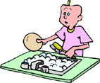 | 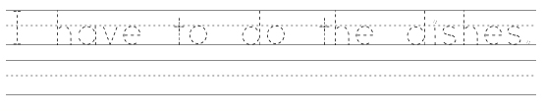
do the dishes
 | 
take out the garbage
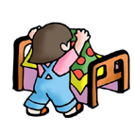
make my bed
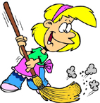
sweep the floor
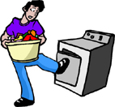 | www.bogglesworldesl.com
do the laundry

