
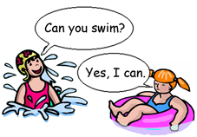 |  | Can you swim?  Yes, I can.  No, I can’t.
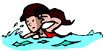 | 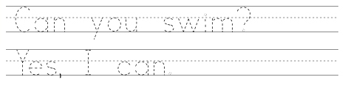
swim
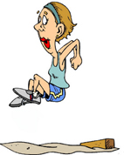 | 
jump
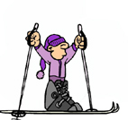
ski

skip rope
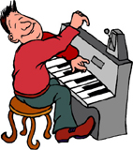
play the piano
www.kroowut.ob.tc

