
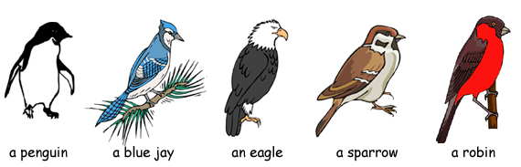
What color are penguins?

What color are blue jays?

What color are eagles?
What color are sparrows?
What color are robins?

© 2009 www.bogglesworldesl.com

