
What are you  going to read?  I’m going to read  a comic book. | 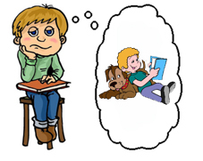

Who are you going to meet?

What are you going to eat for dinner?

Where are you going to go tomorrow?

What are you going to study tomorrow?
What are you going to watch tonight?
When are you going to get up tomorrow?
What are you going to wear tomorrow?
Who are you going to meet tomorrow?
When are you going to go home today?
What are you going to read tonight?
www.bogglesworldesl.com

