
What are you going to do after class?  I’m going to play soccer. | 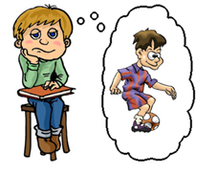
Answer the following questions:

What are you going to do after class?

What are you going to do tomorrow?
What are you going to do on the weekend?

When are you going to go to bed tonight?
www.bogglesworldesl.com

