

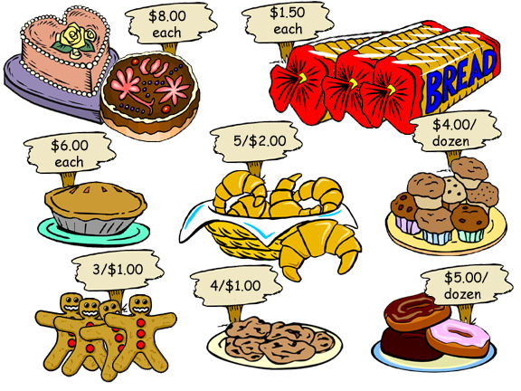

Language for talking about prices:

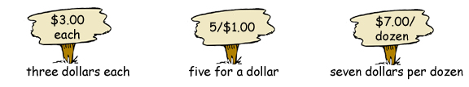

© 2005 www.bogglesworldesl.com

Practice writing

Practice writing:
(1) | 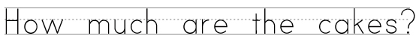
  cakes |  |  | 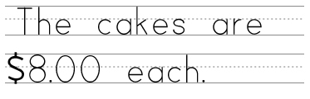
(2) |  | 
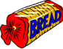  loaves of bread |  |  |  | 

(3)
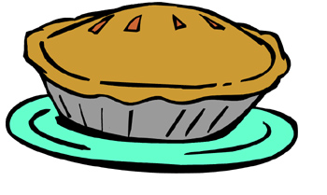
pies
(4)

croissants
© 2005 www.bogglesworldesl.com

(5)
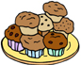
muffins
(6)
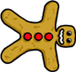
gingerbread cookies.
(7)

cookies.
(8)

donuts

© 2005 www.bogglesworldesl.com

