
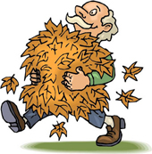
 |  | How many words can you make out of AUTUMN LEAVES?
 |  | A U T U M N L E A V E S
 |  |  | ___________ |  |  | ___________
 |  |  | ___________ |  |  | ___________
 |  |  | ___________ |  |  | ___________
 |  |  | ___________ |  |  | ___________
 |  |  | ___________ |  |  | ___________
 |  |  | ___________ |  |  | ___________
 |  |  | ___________ |  |  | ___________
 |  |  | ___________ |  |  | ___________
 |  |  | ___________ |  |  | ___________
 |  |  | ___________ |  |  | ___________
 |  |  | ___________ |  |  | ___________
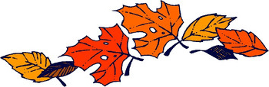

Did you find?
 | Something you drink.
 | A number.
 | What you do at lunch.
 | What you did at dinner.
 | Another word for borrowed.
 | Something you cook.
 | Another word for man.
 | The opposite of freeze.
 | The opposite of spend.
Difficult: | Do a crime.
 | A marine animal.
www.bogglesworldesl.com

