
What can monkeys do?  Monkeys can climb trees. |  | 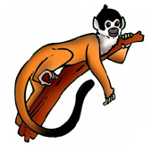
climb trees | What can monkeys do?  
  fly | What can birds do?  
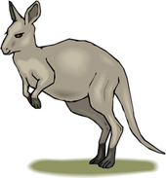  jump | What can kangaroos do?  
  make webs | What can spiders do?  
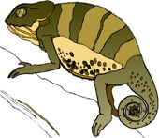  change colors | What can chameleons do?  
www.bogglesworldesl.com

