

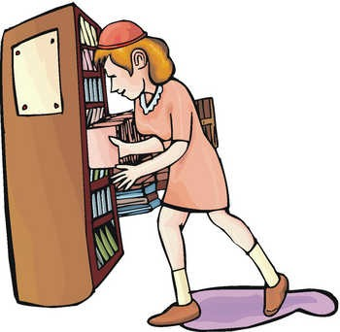 | Why did you go to the library?  I went to the library  to borrow a book.  I went to the library  to return a book.  I went to the library  to study.

Think of two reasons why you might go to each of the following places:

Why did you go to the park?
(1)
(2)

Why did you go to the store?
(1)
(2)

Why did you go to the bank?
(1)
(2)

Why did you go to the gym?
(1)
(2)

Why did you go to the airport?
(1)
(2)
Why did you go to the police station?
(1)
(2)
Why did you go to the lake?
(1)
(2)
Why did you go to the post office?
(1)
(2)
Why did you go downtown?
(1)
(2)

© 2005 www.bogglesworldesl.com

