Many Kinds of Birds

Word focus: some, all

Read the sentences and fill in the blank with some or all.
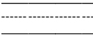 |  |  | birds can fly. | 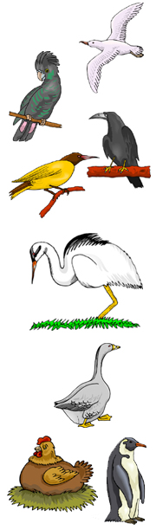
 | birds can swim.
 |  |  | birds lay eggs.
 | birds have feathers.
 |  |  | birds are colourful.
 | birds live in cold places.
 |  |  | birds have beaks.
 | birds live in warm places.
 |  | birds make nests.
 | birds have long legs.
 |  | birds eat fish.
© 2007 Lanternfish

