Lots of Fish in the Sea

Word focus: some, all, none
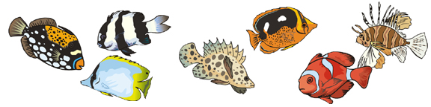
Read the sentences and fill in the blank with some, all, or none.
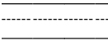 |  | of the fish have fins.
 | of the fish have spots.
 |  | of the fish have legs.
 | of the fish have stripes.
 |  | of the fish have eyes.
 | of the fish have gills.
 |  | of the fish have hands.
 | of the fish have spines.
 |  | of the fish have mouths.
© 2007 Lanternfish

