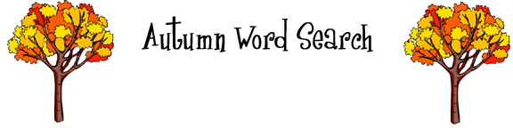
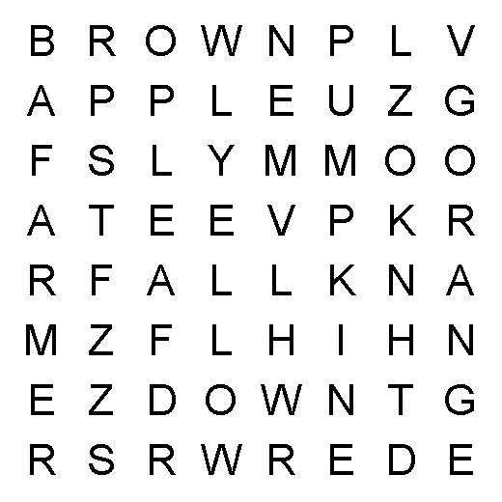

Find all of these autumn words in the grid above:
apple  brown  fall |  | farmer  leaf  orange | pumpkin  red  yellow

© 2005 www.bogglesworldesl.com

