Animal Totem Pole

Word focus: on, a

Read the sentences and fill in the blank with on.
 |  |  |  |  |  | 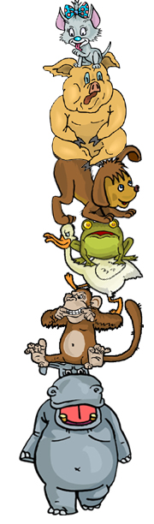
A cat | 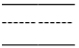 |  | a pig.
A pig |  |  |  |  | a dog.
A dog |  |  |  | a frog.
A frog |  |  |  |  | a duck.
A duck |  |  |  | a monkey.
A monkey |  |  |  |  | a hippo.
What is the hippo standing on?
© 2007 Lanternfish

