I Like . . .
What do you like the most?  I like ice cream. | 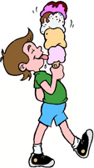
Circle the thing that you like and make a sentence:
dogs | cats | lizards


blue | green | yellow


ice cream | watermelon | hamburgers
winter | summer | fall
corn | carrots | tomatoes

www.bogglesworldesl.com

