I Want . . .
What do you want?  I want a cookie. | 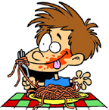

a cookie | an apple | some pizza
an orange | some pizza | some chicken
some water | some juice | some milk
a cherry | a peach | a banana
some rice | a carrot | some corn

www.bogglesworldesl.com

