Part I : Listening - Speaking
Fill in the blanks with appropriate choices of a) , b) , c) or d).
- A : Can I have a piece of cake?
B : ________________
a. Yes, I can. b. That’s good.
c. Of course. Here you are! d. This is a cake.
- A : ________________
B : Oh, I didn’t sleep all night.
a. What did you do last night? b. When did you go to sleep?
c. Do you like to sleep? d. What’s wrong with you?
- Tim : Happy birthday, Tommy. Here’s a present for you.
Tommy : ________________
a. Sorry. I can’t, Tim. b. Thank you for coming, Tim.
c. Don’t forget the birthday. d. You’re welcome.
- A : Hello, can I speak to Miss Hart, please?
B : ________________
a. I’m sorry. I can’t see it. b. It’s nice to meet you.
c. Please, hold on. d. I’ll call him.
- Mary : Dad, may I go out to play?
Dad : ________________
a. You didn’t play all day long. b. No, it is for, Mary.
c. Yes, you may. d. You can help me in the morning.
- A : It’s my great day! I’ve got 98 marks.
B : ________________
a. I’m sorry. b. I’ll tell you.
c. May I call you? d. Congratulations!
- A : What time can we meet?
B : ________________
a. I met him in Thailand.
b. Let’s meet at 4 o’clock in front of the cinema.
c. We’ll meet him in May.
d. I’m sorry. I am not.
- A : What would you like, sir?
B : ________________
a. I like ice-cream. b. I don’t like fried rice.
c. No, thanks. I’m not hungry. d. Chicken salad, please.

- Bob : Tom, how is your brother?
Tom : ________________
a. He is a cowboy. b. He is in Canada.
c. He’ll be back soon. d. He is fine.
- A : Would you like a cup of coffee?
B : ________________
a. No. thanks. I don’t like coffee. b. I don’t want tea.
c. You’re welcome. d. Yes, I will.

Part II : Reading
A. Read the two passages and fill in the blanks with appropriate choices of a) , b) , c) or d).

Passage I
Molly was twelve years old. She had lived with her parents. She never went anywhere by herself, but now her teacher had planed her class to go camping at the National Park for three weeks. Her mother was very sad about this, and she was also afraid because she loved her daughter very much, and she thought, “My little girl will go alone for the first time in her life. Nobody will look after her, and she will be sad because she isn’t with us.”
Molly said goodbye to her parents and to her cat and promised to telephone everyday. When they said goodbye, her mother cried.
Everyday Molly telephoned. She never said that she missed her parents. Her mother was sad about this. But the time had come Molly telephoned her parents, she said, “The students in the camp are happy to return home soon.”
Molly’s mother was very glad to hear that the students had said this. “She must really miss us,” she thought. Then she said, “And you.”
“Oh, yes!” Molly answered. “We all said that it’s easy to speak to our parents on the telephone everyday when we are away, but we really miss our pets!”

- Molly went camping for the first time when __________
a. her parents went away. b. she was sad.
c. she was twelve years old. d. she went there by herself.
- Molly’s mother was not happy because __________
a. she went camping. b. her daughter wasn’t with her.
c. her daughter returned home. d. her daughter didn’t telephone.
- Molly promised to __________
a. her daughter was happy. b. she said goodbye.
c. her daughter really missed her. d. her daughter returned home soon.

- Molly’s mother thought that __________
a. her daughter was happy. b. she said goodbye.
c. her daughter really missed her. d. her daughter returned home soon.
- Molly and her friends really missed their __________
a. parents. b. friends.
c. teachers. d. pets.

Passage II
An octopus is an animal that lives in the sea. This sea animal has a soft body and eight arms. It uses its arms to catch crabs, clams, lobsters, and shellfish. It also uses its arms to open the shell of shellfish so it can eat them. Along these arms are suckers and these can hold on to anything the octopus catches.
When an octopus is in danger. It squirts black ink into the water. Then the octopus can hide from an enemy. The enemy may be a shark, a whale, or a person.

- The best title for this story is __________ .
a. The Happy Shellfish b. The Enemy of Octopus
c. The Amazing Octopus d. The Sea Animal
- “It” in line 2 means __________ .
a. A person b. A shellfish
c. A clam d. An octopus
- This sea animal uses its arms __________ .
a. to catch and open its food b. to squirt black ink into water
c. to beat shellfish d. to kill its enemy
- The octopus squirts black ink into water __________ .
a. and it wants to play
b. if it is not in danger
c. but it meets its friend
d. when it needs to hide from its enemy
- The enemies of the octopus are __________ .
a. crabs, clams and whales
b. sharks, whales and persons
c. clams, shellfish and crabs
d. suckers, arms and persons

B. Look at the temperature chart of Greeley Hill. Study the chart carefully. Then answer the questions. Choose the appropriate choices of a) , b) , c) or d).

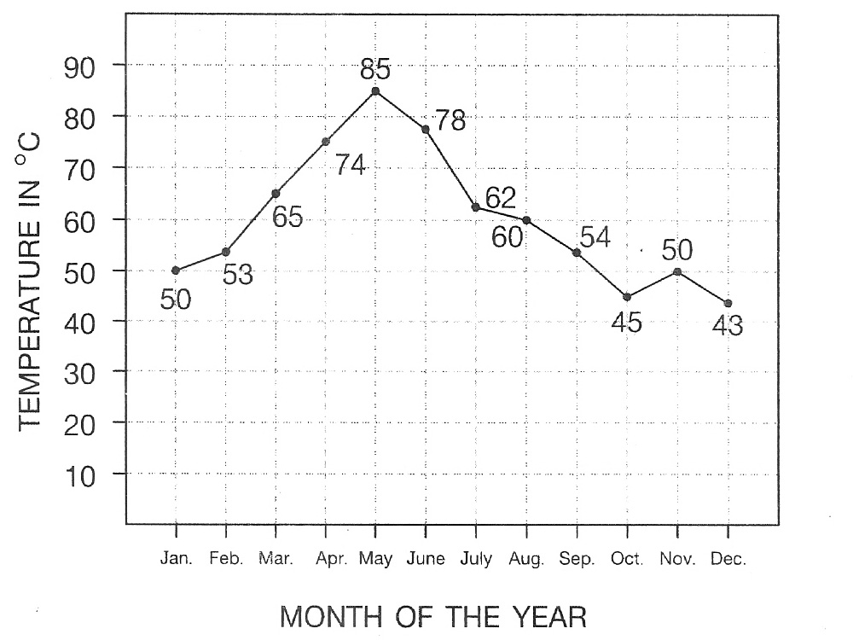

- What is the title of this graph?
a. Temperatures in ⁰C. b. Month of the year in Greeley Hill.
c. Temperatures in Greeley Hill. d. Degrees in Celsius.
- How many degrees is March higher than January?
a. 40 ⁰C b. 30 ⁰C
c. 25 ⁰C d. 15 ⁰C
- Which month is the hottest month of the year?
a. January b. May
c. July d. October
- I do not like hot weather. If I had to visit Greeley Hill. Which month would I choose?
a. December b. October
c. February d. January
- What is the difference in temperature between September and October?
a. 10 ⁰C b. 9 ⁰C
c. 8 ⁰C d. 7 ⁰C

Part III : Writing
A. Look at the table and fill in the blanks with appropriate choices of a) , b) , c) or d).

Name | Somsak | Max | Yoko
Date of birth | Feb. 18, 1960 | Jan. 30, 1954 | Oct. 23, 1988
Age | 48 | 54 | 20
Nationality | Thai | American | Japanese
Appearance | thin & short | fat & tall | thin & short
Hair | short - black | short - white | lang - black
Hobbies | tennis | basketball | badminton
Occupation | doctor | teacher | doctor

- Max is American. He was born in __________ . He is __________ than Yoko for thirty-four years.
a. Japan , younger b. 1988 , thinner
c. America , shorter d. 1954 , older
- Yoko’s birthday is in the __________ month of the year. She was born on _________ .
a. January , Thursday b. tenth , October 23
c. Tuesday , February d. ninth , Friday
- Yoko and Somsak are __________ but Max is a __________ .
a. thin , doctor b. teacher , tennis
c. doctors , teacher d. short , thin
- Somsak likes __________ but Yoko __________ badminton.
a. tennis, likes b. thin , short
c. basketball , has d. doctor , likes
- Somsak __________ a Thai businessman. He __________ short black hair.
a. is , is b. has , has
c. is , has d. have , is

B. Read the letter and fill in the blanks with appropriate choices of a) , b) , c) , or d).

2314/8 Ramkamhaeng Rd.
Bangkapi, Bangkok
Thailand, 10240

_____(31)_____
Dear Pam,
Thank you for your _____(32)_____ . How are you? I’m on holiday with my friends now. My family has a _____(33)_____ by the sea near Pattaya. It’s not _____(34)_____ from Bangkok. We _____(35)_____ a bike everyday. It’s very fun to stay here.
I’ve got a new bike for my 16th _____(36)_____ . It’s red. I ride it along the beach. I can see many _____(37)_____ near the seashore. I found a little pup and took him home. I looked after him. _____(38)_____ name is Spot. He’s black and white. I like to _____(39)_____ with him. What are you doing this summer? Can you come here? We’ll have a lot of fun together. Please write to me soon.
_____(40)_____
Jenny

- a. 2008, January 20 b. May 18, 2008
c. 18, may 2008 d. January, 2008, 20

- a. visit b. asking
c. letter d. invitation

- a. family b. town
c. friend d. house

- a. far b. between
c. next d. out

- a. walk and sail b. play and slide
c. catch and throw d. swim and ride

- a. country b. birthday
c. year d. hometown

- a. sailing boats b. skate boards
c. torpedoes d. strangers

- a. Her b. Your
c. His d. My

- a. kick b. play
c. sing d. watch

- a. Sincerely yours b. Dear friend
c. Your family d. Best wishes

************************************

